제 목: A-Logics UWB Modem Top I/O List v0.1
작성자: 신현욱 선임연구원
작성일: 2007/06/14 (목요일)

- H2 I/O
Table 1 : ASIC Top I/O Description
Group | Name | Bit | IO | Description | Type
System  Control | nRST | 1 | I | Active LOW  H/W reset | LVCMOS
System  Control | eCLK | 1 | I | PLL Input Clock – 33 Mhz LVTTL | LVCMOS
MAC-  PHY  I/F | mac_phy_rst | 1 | I | Active LOW  Asynchronous to PCLK | LVCMOS
MAC-  PHY  I/F | mac_tx_en | 1 | I | Active HIGH  Synchronous to PCLK | LVCMOS
MAC-  PHY  I/F | mac_rx_en | 1 | I | Active HIGH  Synchronous to PCLK | LVCMOS
MAC-  PHY  I/F | mac_phy_active | 1 | O | Active HIGH  Synchronous to PCLK | LVCMOS
MAC-  PHY  I/F | mac_pclk | 1 | O | PHY Clock  Frequency = 66 Mhz for ASIC, 33 Mhz for FPGA version | LVCMOS
MAC-  PHY  I/F | mac_data_en | 1 | O | Active HIGH  Synchronous to PCLK | LVCMOS
MAC-  PHY  I/F | mac_data | 8 | Bi | 8 bit Bus  Synchronous to PCLK | LVCMOS
MAC-  PHY  I/F | mac_sdata | 1 | Bi | Synchronous to PCLK | LVCMOS
RF I/F  Control | TxAtten | 6 | O | TX attenuation | LVCMOS
RF I/F  Control | Rx_FixAtten | 1 | O | Fix attenuation for RF Discrete Board | LVCMOS
RF I/F  Control | RxGainQ | 6 | O | RX Q-ch gain | LVCMOS
RF I/F  Control | RF_SCLK | 1 | O | RF IC serial I/F clock | LVCMOS
RF I/F  Control | RF_SIG0 | 1 | O | RF IC Control | LVCMOS
RF I/F  Control | RF_SIG1 | 1 | O | RF IC Control | LVCMOS
RF I/F  Control | RF_SIG2 | 1 | O | RF IC Control | LVCMOS
RF I/F  Control | RF_SIG3 | 1 | O | RF IC Control | LVCMOS
RF I/F  Control | RF_SIG4 | 1 | O | RF IC Control | LVCMOS
RF I/F  Control | RF_SIG5 | 1 | O | RF IC Control | LVCMOS
RF I/F  Control | RF_SIG6 | 1 | O | RF IC Control | LVCMOS
RF I/F  Control | RF_SIG7 | 1 | O | RF IC Control | LVCMOS
RF I/F  Control | RF_SIG8 | 1 | O | RF IC Control | LVCMOS
RF I/F  Control | RF_SIG9 | 1 | O | RF IC Control | LVCMOS
RF I/F  Control | RF_SIG10 | 1 | O | RF IC Control | LVCMOS
MISC | LED | 2 | O | LED Output | LVCMOS
MISC | RFSEL | 1 | I | RF I/F selection | LVCMOS
MISC | PMode | 2 | I | mac_pclk timing control mux selection | LVCMOS
MISC | CLKMODE | 1 | I | AFE ADC clock output mux selection | LVCMOS
MISC | cdy_div4clk | 1 | O | AFE clock divide output = cdy_div2clk/2 | LVCMOS
MISC | cdy_div8clk | 1 | O | AFE clock divide output = cdy_div2clk/4 | LVCMOS
MISC | cdy_div16clk | 1 | O | AFE clock divide output = cdy_div2clk/8 | LVCMOS
DFT | TCLK | 1 | I | Test Clock Input | LVCMOS
DFT | BistMode | 1 | I | Mode for Bist Memory Test | LVCMOS
DFT | BistFail | 1 | O | Fail output signal for Bist Memory Test | LVCMOS
DFT | BistFinish | 1 | O | Finish indication output signal for Bist Memory Test | LVCMOS
DFT | BistErrMap | 1 | O | Error output signal for Bist Memory Test | LVCMOS
DFT | ScanMode(TM) | 1 | I | Scan Mode (Test Mode) | LVCMOS
DFT | ScanEn | 1 | I | Scan Enable | LVCMOS
PLL  Control | CLKSEL | 2 | I | Input divider control 0:528M, 1:396M, 2:264M, 3:TCLK | LVCMOS
AFE  (Analog) | RX_Q_P | 1 | I | Rx Analog Differential Q positive signal – 1056 Mhz | Analog
AFE  (Analog) | RX_Q_M | 1 | I | Rx Analog Differential Q negative signal – 1056 Mhz | Analog
AFE  (Analog) | RX_I_P | 1 | I | Rx Analog Differential I positive signal – 1056 Mhz | Analog
AFE  (Analog) | RX_I_M | 1 | I | Rx Analog Differential I negative signal – 1056 Mhz | Analog
AFE  (Analog) | iadcx_rext | 1 | I | ADC external resistor pad | Analog
AFE  (Analog) | iadcx_aincm | 1 | O | ADC common mode voltage | Analog
AFE  (Analog) | cdx_clk_p | 1 | I | Ref. Clock (NMOS Differential Input) | Analog
AFE  (Analog) | cdx_vcm | 1 | O | Ref. Clock common mode voltage | Analog
AFE  (Analog) | cdx_clk_m | 1 | I | Ref. Clock (NMOS Differential Input) | Analog
AFE  (Analog) | TX_Q_P | 1 | O | Tx Analog Differential Q positive signal – 1056 Mhz | Analog
AFE  (Analog) | TX_Q_M | 1 | O | Tx Analog Differential Q negative signal – 1056 Mhz | Analog
AFE  (Analog) | TX_I_P | 1 | O | Tx Analog Differential I positive signal – 1056 Mhz | Analog
AFE  (Analog) | TX_I_M | 1 | O | Tx Analog Differential I negative signal – 1056 Mhz | Analog
AFE  (Analog) | idacx_rext | 1 | I | DAC external resistor pad | Analog
AFE  (Analog) | x_atb_p | 1 | I | Analog test bus output + | Analog
AFE  (Analog) | x_atb_m | 1 | I | Analog test bus output - | Analog
AFE  (Analog) | x_guard | 1 | I | P+ isolation guard ring | Analog
LVDS | TXQ | 3 | O | LVDS Tx | LVDS
LVDS | TXQB | 3 | O | LVDS Tx | LVDS
LVDS | VRES | 3 | I | Reference voltage | LVCMOS
LVDS | PWRDN | 3 | I | LVDS power down | LVCMOS

Table 2 : ASIC Top I/O Pin Count
 | SYS | MAC | RF_Ctrl | Misc | DFT | PLL | AFE_A | LVDS | Sum
In | 2 | 3 | - | 4 | 4 | 2 | 11 | 6 | 32
Out | - | 3 | 25 | 5 | 3 | - | 6 | 6 | 48
Bid | - | 9 | - | - | - | - | - | - | 9
Sum | 2 | 15 | 25 | 9 | 7 | 2 | 17 | 4 | 89

- CLOCK
iCLK4와 iCLKx2는 rising edge가 최대한 같은 시점에 동작할 것(오차 범위 300ps 이내)

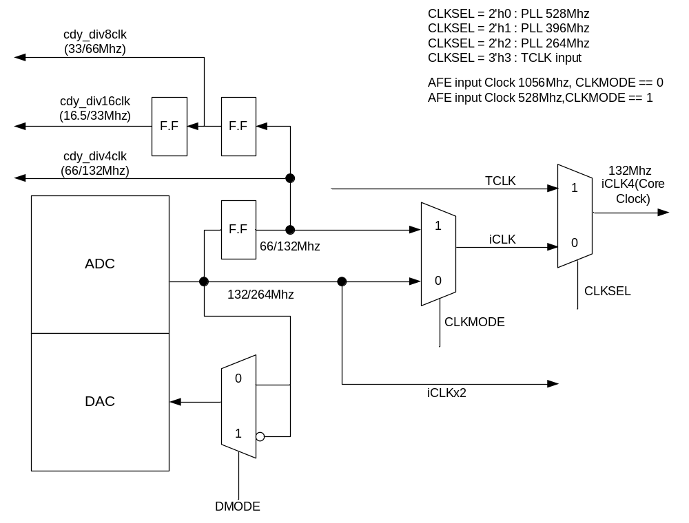
Figure 1 : Internal Clock
- Reset
Minimum reset time : PLL lock 기준으로 550us 시간이 필요함.

- DFT
- SCAN
- BIST
- TestVector

